## Cabin Baggage

You must issue one ticket for both the passenger and the cabin baggage.

**Steps for booking a cabin baggage and issuing the ticket**

1. Create 2 name elements in one transaction. Include the ID Code (IDCBBG) in the first name element for the passenger, and enter CBBG as the first name in the second name element for the cabin baggage

Do not enter a title in the second name element for the cabin baggage.

NM2JOHNSON/SUZY MS(IDCBBG)/CBBG

RP/MRUMK0983/

RF EF

1.JOHNSON/SUZY MS(IDCBBG) 2.JOHNSON/CBBG

1. Book 2 seats and create an SSR element for the cabin baggage, associating the SSR with the passenger

SRCBBG-MUSICAL INSTRUMENT ONE CELLO/P1

RP/MRUMK0983/

RF EF

1.JOHNSON/SUZY MS(IDCBBG) 2.JOHNSON/CBBG

3 MK 646 X 16MAY 1 MRUKUL HK2 2040 0950+1 332 E 1 M

MKMH CODESHARE OPTE BY AIR MAURITIUS

7DYS TO DEPARTURE DATE NN IMMEDIATE TKTG

PLS DELETE MK HX NO UC UN SEGMENT TO AVOID ADM

SEE RTSVC

4 MK 647 X 24MAY 2 KULMRU HK2 M 1345 1855 332 E 1 M

MKMH CODESHARE OPTE BY AIRMAURITIUS

7DYS TO DEPARTURE DATE NN IMMEDIATE TKTG

PLS DELETE MK HX NO UC UN SEGMENT TO AVOID ADM

SEE RTSVC

5 SSR CBBG MK HK1 MUSICAL INSTRUMENT ONE CELLO/S3/P1

6 SSR CBBG MK HK1 MUSICAL INSTRUMENT ONE CELLO/S4/P1

1. Create one TST for both the passenger and the CBBG.

FXP/P1 or TTC/P1

1. Include the appropriate ticket designator “CB” for cabin baggage in the fare basis of the TST.

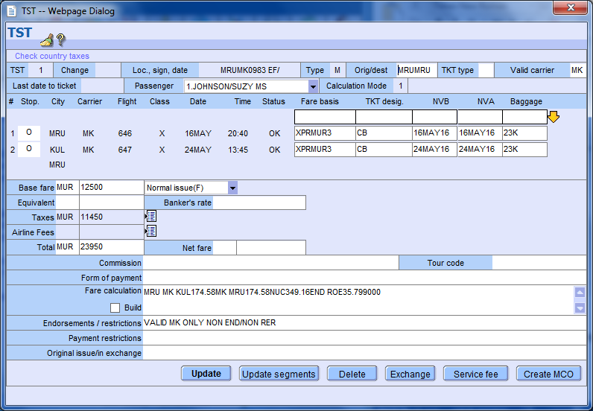

1. Update the Base Fare by adding the CBBG surcharge to the base fare amount

Base fare field: base fare amount X2

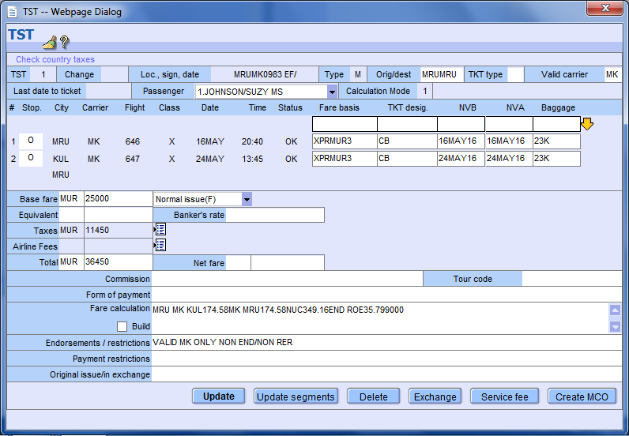

Normal fare MUR12500X2

1. Taxes: quote taxes for 1 passenger except YQ tax which should be charged twice

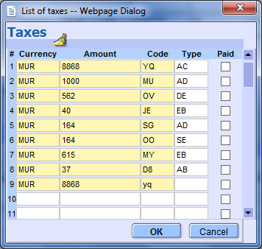

1. Include the cost of baggage as a Q surcharge in the fare calculation line of the TST.

**Note the amount should be in NUC**

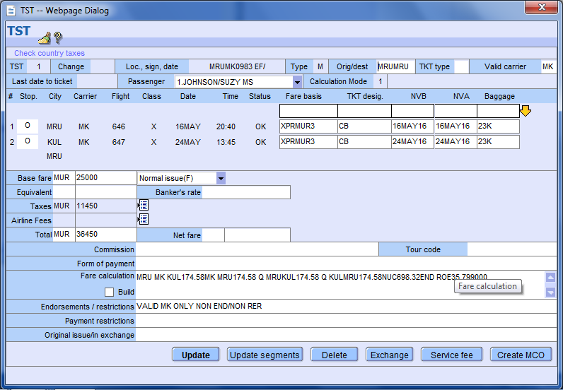

CBBG surcharge for

outbound and inbound

1. Issue the E-TKT

TTP/P1/RT

Display of the PNR after issuance

--- TST RLR ---

RP/MRUMK0983/MRUMK0983 EF/SU 21APR16/0712Z YMBE2C

1.JOHNSON/SUZY MS(IDCBBG) 2.JOHNSON/CBBG

3 MK 646 X 16MAY 1 MRUKUL HK2 1940 2040 0950+1 *1A/E*

4 MK 647 X 24MAY 2 KULMRU HK2 M 1345 1855 *1A/E*

5 AP MRU 2077234 - HELPDESK OFFICE - A

6 TK TL20APR/MRUMK0983

7 TK PAX OK21APR/MRUMK0983//ETMK/S3-4/P1

8 SSR CBBG MK HK1 MUSICAL INSTRUMENT ONE CELLO/S3/P1

9 SSR CBBG MK HK1 MUSICAL INSTRUMENT ONE CELLO/S4/P1

10 FA PAX 239-2114025865/ETMK/MUR45318/21APR16/MRUMK0983/007739 *FA element is associated to*

86/S3-4/P1

11 FB PAX 2100000038 TTP OK ETICKET/S3-4/P1 *passenger 1 only*

12 FE PAX VALID MK ONLY NON END/NON RER/S3-4/P1

13 FP CASH

14 FV PAX MK/S3-4/P1

Since no FA will be associated to CBBG, **you will need to send a message to Reservation Control to ensure that no cancellation is done by ARI**.

Display of ETKT

TKT-2392114025865 RCI- 1A LOC-YMBE2C

OD-MRUMRU SI- FCMI-1 POI-MRU DOI-21APR16 IOI-00773986

1.JOHNSON/SUZY MS ADT S I

1 OMRU MK 646 X 16MAY2040 OK XPRMUR3/CB O 16MAY16MAY 23K

2 OKUL MK 647 X 24MAY1345 OK XPRMUR3/CB O 24MAY24MAY 23K

MRU

FARE F MUR 25000

TOTALTAX MUR 20318

TOTAL MUR 45318

/FC MRU MK KUL174.58MK MRU174.58 Q MRUKUL174.58 Q KULMRU174.58NU

C698.32END ROE35.799000

FE VALID MK ONLY NON END/NON RER

FP CASH

FOR TAX/FEE DETAILS USE TWD/TAX